Assignment-01 CN5006

Field | Detail
Name | Sakar Shrestha
Student ID | 2866703
Submission Date | 14th November 2025
Assignment Weight | Two Marks

Captured results and demonstration
- Addition Demonstration
- Operation: 9+3
- Expected Result:12
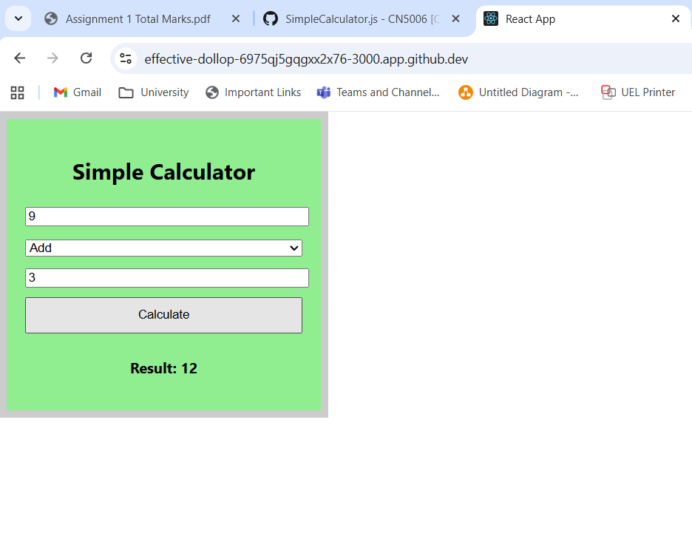
- Subtraction Demonstration
- Operation:9-3
- Expected Result:6
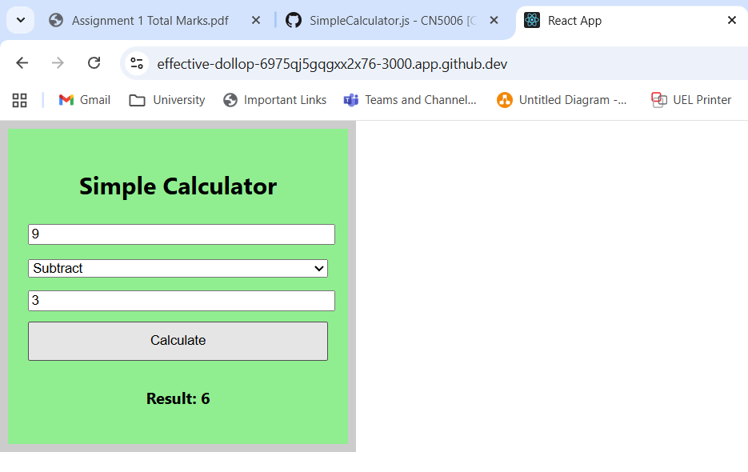
- Multiplication Demonstration
- Operation:9*3
- Expected Result:27
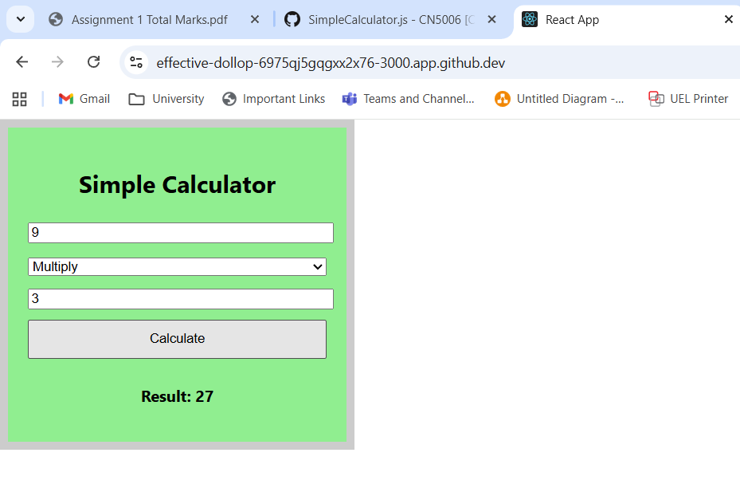
- Division Demonstration
- Operation:9/3
- Expected Result:3
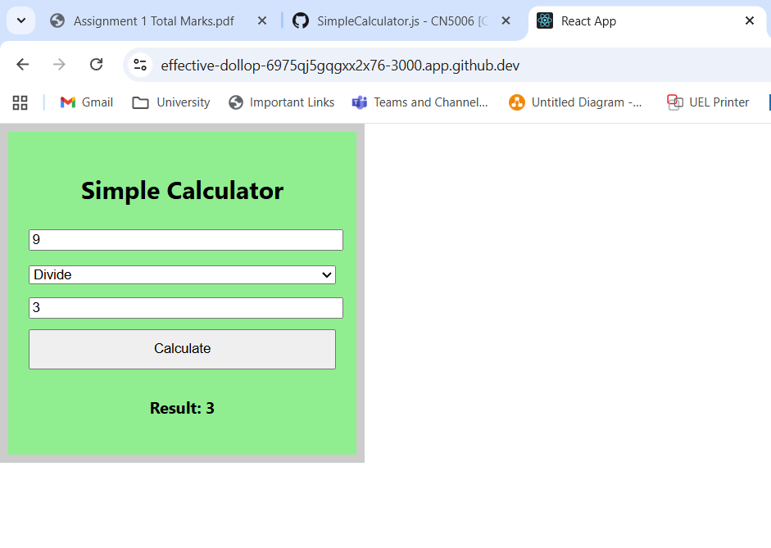

Program Execution and Component Explanation
The calculator app is made with React and has only one functional component called Calculator.
The "Calculate" button starts the calculate function, which is the main part of the component. This function uses regular JavaScript to get the two numbers (num1 and num2) and the math operator that was chosen from the dropdown list. Then, a JavaScript switch statement takes care of the logic by doing the right operation (addition, subtraction, multiplication, or division) based on the value of the operator. The division case has a check to make sure that you don't divide by zero. Finally, the screen shows the calculated result in real time.
I ran the program in a GitHub Codespaces setting. I first went to the project directory (/myapp) and ran npm install to make sure that all the necessary packages, like react-scripts, were available. Then, I ran the command npm start to start the application. This compiled the React app and served it through Codespaces port forwarding, which let me test all the features.

